l/sel/Ë g]kfn dlxnf -dlxnf nfu'cf}ifw k|of]ustf{x?sf] /fli6«o ;~hfn_
Recovering Nepal Women (National Network of Women who Use Drugs)

aflif{s k|ltj]bg
Recovering NEPAL Women | Kumaripati, Lalitpur
-cf=j @)*!÷*@_

s]lGb«o sfof{no
s'df/Lkf6L, nlntk'/, g]kfn
Email: rnwomen@rnwomen.com

BOARD MEMBER OF RN-WOMEN
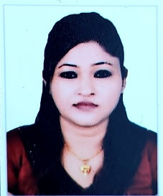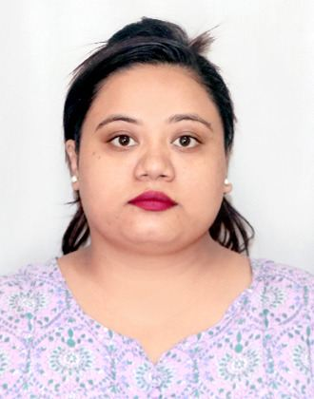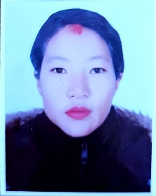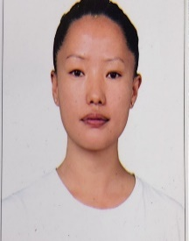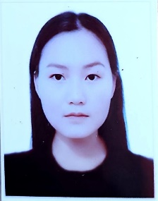
Hema Shrestha Simran Rajbhandari Prachi Sunuwar Bigens Nembang Sarala Tamang
President Vice-President General Secretary Treasurer Secretary
Bagmati Province Lumbini Province Bagmati Province Bagmati Province Koshi Province

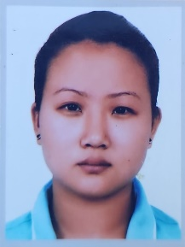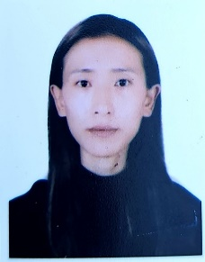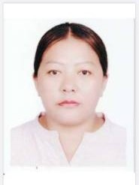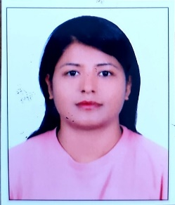
Yamkala Rai Doma Sherpa Sommaya Gurung Janaki Shrestha
Member Member Member Member
Bagmati Province Bagmati Province Gandaki Province Bagmati Province

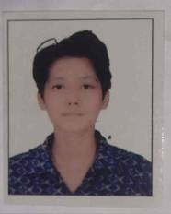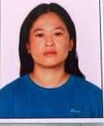

Rejina Pokhrel Sarita Lama
Member Member
Koshi province Bagmati Province

RECOVERING NEPAL WOMEN PROVINCIAL COVERAGE
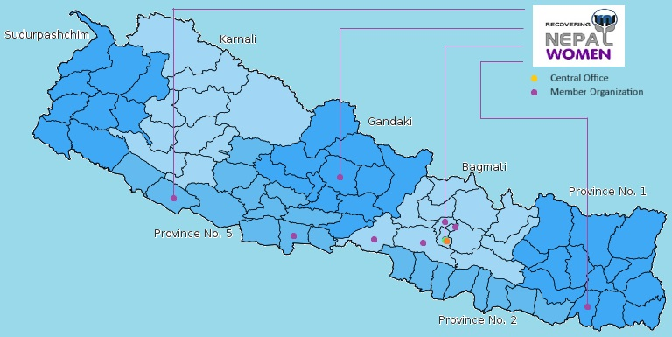

l/sel/Ë g]kfn dlxnfsf] cf=j @)*!÷*@ sf] o; ;+:yfsf
cWoIfsf]
k|:t't aflif{s k|utL k|ltj]bg

o; ;+:yfsf] aflif{s ;fwf/0f ;efdf kfNg'x'g] k|d'v cltlyHo', ljz]if cltlyHo', cfdlGqt ;Dk'0f{ cltlyHo'x?, ;+:yfks ;b:oHo'x?, ;+:yfsf k'j{ tyf jt{dfg ;~rfns ;ldltsf kbflwsf/LHo'x? Pj+ ;b:oHo'x? tyf ;+:yfsf ;Dk'0f{ sd{rf/Lju{df ;+:yfsf] cWoIfsf] tkm{af6 xflb{s clejfbg tyf :jfut ug{ rfxG5' .
g]kfn ;/sf/ u[xdGqfnon] s]lGb|o tYof ljefusf] kxndf lj= ;+= @)*! df lgsfn]sf] tYofÍ cg';f/ g]kfndf s8f nfu" cf}ifw k|of]ustf{sf] cg'dflgt ;+Vof $**%& h:df k'?if $$#&@ -()=*Ü_ / $$*$ -(=!&Ü_ dlxnf nfu" cf}ifw k|of]ustf{x? /x]sf] ;f]lx k|ltj]bg cg';f/ jflif{s %=)^Ü cf}ift j[4L b/ /x]sf] b]vfPsf] 5 . tYofÍ cg';f/ ljz]if ul/ !% jif{ b]lv #) jif{sf] pd]/sf eljiosf s0f{wf/ o'jfo'jtLx? -&&Ü_ / dlxnfx? dfq *$=(Ü nfu" cf}ifwsf] hf]lvddf /x]sf] b]lvG5 . nfu" cf}ifw k|of]ustf{x?sf] j9bf] ;+Vof /x]sf]n] xfn ljBdfg ;/sf/L ;+/rgfn] ;d:ofsf] ;dfwfg ug{ g;Sg] ePsf]n] ;/sf/s} k~rjlif{o u'? of]hgf cg'?k g]kfnsf] tLg} txsf ;/sf/x?n] o; ;d:ofsf] lj?4 j[xb ?kdf sfo{ ug{' kg]{ b]lvPsf] 5 .
ut @)!& b]lv l/sel/ª g]kfn dlxnfn] Pp6f n'h u|'ksf] ?kdf nfu'cf}ifw k|of]ustf{ lbbL alxgLx?sf] nflu lg/Gt/ ?kdf sfd ub}{ cfO{/x]sf] / ;g\ @)!* hgj/L !@, df b]z el/ s} nfu'cf}ifw k|of]ustf{ lbbL alxgLx?sf] If]qLo tyf /fli6«o :t/sf] e]nf dfkm{t cflwsfl/s ¿kdf n'h u|'knfO{ l/sel/ª g]kfn dlxnf eg]/ 3f]if0ff ul/Psf] lyof] . ;g\ @)@), hgj/L @ df l/sel/ª g]kfn dlxnfnfO{ sfg'gL ?kdf btf{ ul/of] / cflwsfl/s ?kdf dlxnf nfu'cf}ifw k|of]ustf{x?sf] /fli6«o ;~hfnsf] ?kdf 3f]if0ff ul/of] . l/sel/ª g]kfn dlxnf k'j{ dlxnf nfu'cf}ifw k|of]ustf{x?sf] g]t[Tjdf / g]kfndf nfu'cf}ifw k|of]u ug]{ dlxnfnfO{ lx+;f, e]befj, b'j{\ojxf/, ;LdfGtLs/0f / pk]lIftaf6 hf]ufpg] p2]Zon] vf]lnPsf] /fli6«o ;~hfn xf] / o;n] dlxnf nfu' cf}ifw k|of]ustf{sf] nflu b]z} e/L sfo{ ub}{ cfO{/x]sf] 5 .
l/sel/ª g]kfn dlxnfn] k'gM k|flKtsf] p2]Zo nfu"cf}ifw -WUDs_ k|of]u ug]{ dlxnfx¿sf] hLjgsf] u'0f:t/ ;'wf/ ug]{ gLltx¿nfO{ k|efj kfg]{, pgLx¿sf clwsf/x¿ k'g;{\yflkt ug]{ / Pp6f l;h{gf ug]{ nIo /fv]sf] 5 . l/sel/ª g]kfn dlxnfn] PrcfO{eL, n}lËs ;+j]bgzLn, IotL Go"gLs/0f ;]jfx¿, sn+s, e]befj / lx+;fsf] cGTo ug]{, of}g k|hgg :jf:Yo / clwsf/ nfO{ k|jb{\wg ug]{x¿sf] clwsf/sf] jsfnt ub}{ / ltgLx¿sf ;+:yfx¿sf] k|ltlqmofsf] IfdtfnfO{ ;'b[9 kfg]{ sfo{df hf]8 lbb}+ cfO/x]sf] 5 .
Vision
- dlxnf nfu'cf}ifw k|of]ustf{nfO{ ;dfhdf dof{lbt, :jf:y / ;lqmo hLjg latfpg] kl/sNkgf ub{5 .
Mission
- ;fdflhs Gofo, n}lËs ;dfgtf / dfgj clwsf/nfO{ cufl8 a9fpg] gLlt / sfo{qmdx?sf] ;'wf/nfO{ ult lbg dlxnf nfu'cf}ifw k|of]ustf{ / dlxnf g]t[Tjdf v8f ePsf ;+:yfx?nfO{ ;zlSts/0f ug]{ xf] .
Goal
- g]kfndf dlxnf nfu'cf}ifw k|of]ustf{x?sf] ;a} gLlt th'{df / sfo{qmdsf r/0fx? h:t} of]hgf, sfo{Gjog, cg'udg / d"NofÍgdf cy{k"0f{ ;xeflutfsf] ;'lglZrt ug]{ .
Objective
- dlxnf nfu'cf}ifw k|of]ustf{x?sf] hLjgsf] u'0f:t/ j[l¢ ug]{ gLltx?nfO{ k|efj kfg]{, pgLx?sf] :jf:Yo clwsf/x? k'g:yf{lkt ug]{, dlxnf ;zlSts/0fnfO{ k|j4{g ug]{, nfu'cf}ifwsf] k|of]usf] Ifltx?nfO{ Go"lgs/0f ug]{ -/ut hGo ;+s|d0f ;lxt_, / cTofjZs ;]jfx?df kx'+rsf] nflu ;xh jftfj/0f lgdf{0f ug]{ .
cfufdL of]hfgfx?
- sfg'gL tyf gLltut jsfnt, k}/jL tyf k|fljlws ;xof]u
- kf/bzL{ Aoj:yfklso cEof;x?,
- k|efjsf/L ljlQo Aoj:yfkg,
- kl/of]hgfnfO{ yk k|efjsf/L / lbuf] agfpg]
- g]kfn ;/sf/ u[x dGqfno / :jf:Yo dGqfnon] hf/L u/]sf] sfo{lgltnfO{ k|fyldStfdf /flv sfo{ ug]{ .
- g]kfndf nfu' cf}ifw k|of]u ug]{ dlxnfx?sf] lhjgdf lg/Gt/ ?kdf ;sf/fTds k|efj kfg{sf] nfuL ;'lglZrt ug]{
- lg/k/flws/0f, Gofodf kx'Fr / sfg'gL ;xfotf
- pkrf/ / k"g{:yfkgf s]Gb|df u'0f:t/Lo Ps?ktfsf ;]jfx?df hf]8

cGTodf o; ;+:yfn] cfkmgf] ;fwg, >f]t tyf ;fdY{on] EofP;Dd sfo{ ub}{ cfO{/x]sf] t/ klg o; If]qdf ljljw r'gf}tLx?df nfu'cf}ifw lzIff tyf ;r]tgf / k'g:yf{kgf pkrf/ ;]jfdf cem k|efjsf/L 9Ën] ;|f]t / ;fwgsf] sdLn] ;f]r] cg'?k sfd ug{ g;s]sf] hfgsf/L u/fpg rfxG5' . cfufdL lbgdf dflysf r'gf}tL tyf ;d:of ;dfwfgfy{ o; ;:yfn] ljif]z sfo{of]hgf agfO{ nfu" ug]{ / ;xof]usf] kl/rfng ug]{5 . ;+:yfsf ;Dk'0f{ ;b:o, g]kfn ;/sf/sf ;DalGwt lgsfox?, s]lGb«o, k|b]z tyf :yfgLo ;/sf/, k|fb]lzs sfo{sf/L ;ldlt, kqsf/, ;/f]sf/jfnf ;+3;+:yfx?, sd{rf/Lx? / :j+o;]jsx? ;a}nfO{ xflb{s wGojfb lbb} cfufdL lbgx?df klg ;xsfo{, ;dGjo / ;xof]usf] ck]Iff u/]sf] 5' .

wGojfb
cWoIf
x]df >]i7
l/sel/Ë g]kfn dlxnf

l/sel/Ë g]kfn dlxnfsf] cf=j @)*!÷*@ sf] o; ;+:yfsf
dxf;lrjsf]
k|:t't aflif{s k|utL k|ltj]bg

gd:sf/,
o; ;+:yfsf] aflif{s ;fwf/0f ;efdf kfNg'x'g] k|d'v cltlyHo', ljz]if cltlyHo', cfdlGqt ;Dk'0f{ cltlyHo'x?, ;+:yfks ;b:oHo'x?, ;+:yfsf k'j{ tyf jt{dfg ;~rfns ;ldltsf kbflwsf/LHo'x? Pj+ ;b:oHo'x? tyf ;+:yfsf ;Dk'0f{ sd{rf/Lju{df ;+:yfsf] dxf;lrjsf] tkm{af6 xflb{s clejfbg tyf :jfut ug{ rfxG5' .
l/sel/Ë g]kfn dlxnfn] dlxnf nfu" cf}ifw k|of]ustf{x?sf] ;jfn / ;d:of ;dfwfgfy{ cfkm\gf] :yfkgfsfn @)!* b]lv g]kfn ;/sf/, u[x dGqfno, :jf:y tyf hg;+Vof dGqfno, nfu" cf}ifw lgoGq0f zfvf ;+u ;dGjo / ;xsfo{ ub}{ cfO{/x]sf] hfgsf/L u/fpg rfxG5' . o; ;+:yfn] cfkm\gf] :yfkgf sfn b]lv nfu" cf}ifw k|of]ustf{x?sf] / ;+3 ;:yfsf]x?sf] ;jfndf sfd ug{ ljleGg bfqL lgsfox?df (INPUD, Global Fund, Save the Children,UNDP, IDPC, WHRIN, NAPUD) cflb ;+u ljleGg kl/of]hgfdf sfd u/]sf] 5 .

l/sel/Ë g]kfn dlxnfåf/f o; cfly{s jif{df s]lGb|o, k|b]lzs / lhNnf :t/df u/]sf] sfo{qmdx?sf] ;+lIfKt pknlAwx? k|:t't ug{ rfxG5' .
- l/sel/Ë g]kfn dlxnfn] Iflt Go'lgs/0f sfo{qmd cGtu{t sf7df08f}, eStk'/, nlntk'/, sf:sL, ;'G;/Ldf rf/ ;fem]bf/ :yflgo ;+:yfx?åf/f -dlxnf ;xof]uL ;d'x, ;f]e/ l/se/L P08 l6«6\d]G6 ;]G6/, sDo'lg6L ;kf]{6 u|'k, hfu/0f cf/f]Uo ;d'x_ lgoldt Pr=cfO{=eL /f]syfd ;]jf k|bfg ub}{ cfO/x]sf] 5 .
- o; cfly{s jif{df l/sel/Ë g]kfn dlxnfåf/f ;+rflnt Iflt Go'lgs/0f sfo{qmd cGt{ut !#%$ ;]jfu|fxLx?n] ;'O{ ;f6f;f6 sfo{qmdaf6 ;]jf lnPsf 5g\ .
- cfly{s jif{ )*!/)*@ Dff, o; ;+:yfåf/f !!!# hgf ;]jfu|fxLx?sf] HIV kl/If0f ul/of] .
- x/]s lhNnfx?df @–@ j6f ul/ hDdf !) j6f ;/f]sf/jfnfx? ;+usf] cGt/lqmof sfo{qmd ;DkGg ul/of] h;af6 !!@ ;/f]sf/jfnfx? ;+u ;dGjo ul/of] h:df ;/sf/L sd{rf/L, :yfgLo ;/sf/, OCMC, nfu'kbfy{ tyf Pr= cfO{= eL df sfd ug]{ ;+3;+:yfx? / dlxnfåf/f ;+rflnt sfo{nox?sf] pkl:ylt lyof] .
- x/]s lhNnfx?df @–@ j6f ul/ !) j6f k|x/L k|zf;g ;+usf] cGt/lqmof sfo{qmd ;DkGg ul/of] .
- cfly{s jif{ )*!/)*@ Dff s]lGb|o sfo{noåf/f ;fem]bf/ ;+:yfx?sf] $ rf]l6 cg'udg tyf d'NofÍg ul/of], ;fy–;fy} :yflgo ;/sf/ / ;DalGwt ;+:yfsf sfo{sf/L ;b:ox? åf/f sfo{of]hgf cg';f/ jflif{s ?kdf ul/g] ! rf]l6 ;+o'St cg'udg e|d0f ul/of] .
o; afx]s klg l/sel/Ë g]kfn dlxnfn] dlxnf nfu'cf}ifw k|of]ustf{x?sf] ;du| ljsfz, ;zlQms/0f / ;Ddflgt lhjgsf] nfuL u/]sf sfo{ tyf k|ofzx? o; k|sf/ 5g\ .
- ;+l3o, k|b]z tyf :yfgLo :t/ tyf ;/f]sf/jfnfx?df ;dGjo tyf ;xsfo{ :yfkgf .
- ;+l3o, k|b]z tyf :yfgLo :t/ tyf ;/f]sf/jfnfx?df nfu'cf}ifw k|of]ustf{x?sf] ;jfnx? Aff/]df jsfnt, k}/jL .
- Iflt Go'gLs/0fsf sfo{qmdx?df dlxnfx?nfO{ ;zlQms[t ub}[{ pgLx?s} g]t[Tjdf dlxnf nfu'cf}ifw k|of]ustf{x?sf] kx'Fr j[l4 .
- ljleGg ;/sf/L tyf u}/;/sf/L ;+3;+:yfx?;+u ;xof]u cfbfgk|bfg tyf ;dGjo .

cGTodf o; ;+:yfsf] jflif{s e]nfdf kfNg'x'g] k|d'v cltlyHo', ljz]if cltlyHo', cfdlGqt ;Dk'0f{ cltlyHo'x?, ;+:yfks ;b:oHo'x?, ;+:yfsf k'j{ tyf jt{dfg ;~rfns ;ldltsf kbflwsf/LHo'x? Pj+ ;b:oHo'x? tyf ;+:yfsf ;Dk'0f{ sd{rf/Lju{df ;+:yfsf] dxf;lrjsf] tkm{af6 xflb{s xflb{s wGojfb lbb} cfufdL lbgx?df klg ;xsfo{, ;dGjo / ;xof]usf] ck]Iff u/]sf] 5' .
wGojfb

dxf;lrj
k|flr ;'g'jf/
l/sel/Ë g]kfn dlxnf

l/sel/Ë g]kfn dlxnfsf] cf=j @)*!÷*@ sf] o; ;+:yfsf]
sf]iffWoIf
k|:t't aflif{s k|utL k|ltj]bg

o; ;+:yfsf] aflif{s ;fwf/0f ;efdf kfNg'x'g] k|d'v cltlyHo', ljz]if cltlyHo', cfdlGqt ;Dk'0f{ cltlyHo'x?, ;+:yfks ;b:oHo'x?, ;+:yfsf k'j{ tyf jt{dfg ;~rfns ;ldltsf kbflwsf/LHo'x?, k|b]lzs sfo{sf/L ;b:o Ho' Pj+ ;b:oHo'x? tyf ;+:yfsf ;Dk'0f{ sd{rf/Lju{df ;+:yfsf] sf]iffWoIfsf] tkm{af6 xflb{s clejfbg tyf :jfut ug{ rfxG5' .

cf= j= @)*!÷*@ Dff o; ;+:yfn] dlxnf nfu'cf}ifw k|of]ustf{ ;fy} o; 5ftf ;+u7gdf cfj4 ;b:o ;+:yfx?sf] xs, lxt / clwsf/, Ifdtf clej[l4, ;fy} lgltlgod tyf sfg'g kl/jt{gsf] nfuL cfjfh lg/Gt/ ?kdf p7fpb} cfO{/x]sf] af/] k'gM :d/0f u/fpg rfxG5' . o; ;+:yfn] cfkmgf] lgoldt ultljlw afx]s ljeGg bft[ lgsfosf] cfly{s tyf k|fljlws ;xof]udf kl/of]hgfx? ;~rfng u/]sf] lyof] . nfu' cf}ifw k|of]ustf{x?sf] cfd;jfnx? ;Daf]wg ug{ ;]jfd'vL / u}/gfkmfd'ns ;+:yf ePsf] x'gfn] ;Dk'0f{ ;+:yfsf cfo Aoox?nfO{ g]kfn ;/sf/sf] cfly{s lgodfjnL, ;+:yf tyf bft[lgsfox?sf] cfly{s lglt, lgod / ;Demf}tf cg';f/ n]vf k|0ffnL ;+rfng ul/Psf] 5 . kl/of]hgf ;~rfng ug]{ qmddf ;+:yfsf] cfly{s lgodfjnLx?sf] kfngf ub}{, bft[lgsfox?sf] cfly{s tyf sfo{qmd cg'udgsf] tyf n]vf kl/If0fsf] qmddf b]lvPsf] sdL, sdhf]/Lx?nfO{ ;Rofpb} o; ;+:yfn] cfly{s tyf n]vf k|0ffnLnfO{ r':tf b'?:t /fv]sf] 5 .

o; ;+:yfsf] n]vf k|0ffnL ljut $ jif{ b]lv Accounting software Tally df ub}{ cfO{/x]sf] hfgsf/L u/fpg rfxG5' . o; cf= j= @)*!÷*@ Dff Save The Children, UNDP, Global Fund and NAPUD kl/of]hgf cGt{ut bft[lgsfox?;+u k|fKt /sd / ;+:yfsf] cfGt/Ls ;|f]tsf] vr{ ?= !*,&),@*)( -Ps s/f]8 ;tf;L nfv b'O{ xhf/ cf7 ;o gf}_ vr{ ePsf] 5 / vr{sf] j[:tLt ljj/0f n]vf kl/If0f k|ltj]bgdf k|:t't ul/Psf] 5 . kl/of]hgfsf] ;dofjlw cg';f/ afFsL sfo{qmdnfO{ rfn' cfly{s aif{df lgod cg';f/ lg/Gt/tf lbO{/x]sf] hfgsf/L u/fpg rfXG5' .

cGTodf o; ;+:yfn] cfkmgf] ;fwg, >f]t tyf ;fdY{on] EofP;Dd /fli6«o :t/df sfd ub}{ cfO{/x]sf]df ;+:yfsf ;Dk'0f{ ;b:o, g]kfn ;/sf/sf ;DalGwt lgsfox?, s]lGb«o, k|b]z tyf :yfgLo ;/sf/, k|fb]lzs sfo{sf/L ;ldlt, kqsf/, ;/f]sf/jfnf ;+3;+:yfx?, sd{rf/Lx? / :j+o;]jsx? ;a}nfO{ xflb{s wGojfb lbb} cfufdL lbgx?df klg ;xsfo{, ;dGjo / ;xof]usf] ck]Iff u/]sf] 5' .

wGojfb
lju]G; g]Dafª
sf]iffWoIf,
l/sel/Ë g]kfn dlxnf

Table of Content
LIST OF ABBREVIATION IX
EXECUTIVE SUMMARY XI
1. Background and Introduction of RN Women ii
Mission: ii
Vision: ii
Goal: ii
2. RN Women Structure iii
3. RN Women Staff members under global fund project iv
4. RN Women Implementing Partners under Global Fund Project iv
5. Major Activities of RN Women iv
6. Save the children project of WUDs/WWID till January 2025 & UNDP From February 2025 v
a. Activities carried out by implementing partners vi
7. Activities carried out by RN Women vii
a. M&E Visit was completed to Kathmandu, Lalitpur, Kaski and Sunsari vii
b. Board Meeting viii
c. Support Don’t Punish Campaign ix
8. Extra Activities xi
a. SR review meeting 12-13 December 2024 xi
b. xi
c. xi
d. Provincial-level annual review on HIV, sexually transmitted diseases, hepatitis, and OST/N-related programs xii
e. xii
9. Program Target Vs. Achievement of 2081/082 xii
a. RN Women Harm Reduction Target Vs. Achievement xii
b. BCC Reach Vs. Achievement of 081/082 xiii
c. BCC Reach and HIV testing xiv
d. Syringe Distribution xv
e. Syringe OUT/Syringe IN xv
f. Syringe Out and Syringe per person per month xvi
g. Condom Distribution xvi
10. Conclusion xvii

LIST OF ABBREVIATION

AIDS: Acquired Immunodeficiency Syndrome
BCC: Behavior Change Communication
CANN: Coalition of AIDS Network in Nepal
CBOs: Community Based Organizations
CSS: Community System Strengthening
CCMN: Country Coordinating Mechanism Nepal
CLT: Community Led Testing
CRG: Community, Rights, Guidelines
DIC: Drop-In Centers
DHIS2: District Health Information System
FSGMN: Federation of Sexual and Gender Minorities Nepal
GF: Global Fund
HR: Harm Reduction
HIV: Human Immunodeficiency Virus
HIVST: HIV Self-Testing
IBBS: Integrated Biological and Behavioral Surveillance
IDPC: International Drug Policy Consortium
INPUD: International Network of People Who Use Drugs
IRW: In-Reach Worker
KP: Key Population
MOHP: Ministry of Health and Population
NAPN+: National Association of PLWHA in Nepal
NFWLHA: National Federation of Women Living with HIV and AIDS
NHRC: National Human Rights Commission
NCASC: National Centre for AIDS and STD Control
NSP: Needle Syringe Program
ODA: Organization Development and Advocacy
OST: Opioid Substitution Therapy
OSDV: On-site Data Verification
OCMC: One-stop Crisis Management Center
OPMIS: Online Program Management Information System
PWID: People Who Inject Drugs
PLWHA: People Living With HIV and AIDS
ROB: Rules of Business
SCI: Save the Children International
SRH: Sexual and Reproductive Health
SSP: Standard Service Package
SWOT: Strength, Weakness, Opportunity, Threat
UNDP: United Nations Development Program
WHRIN: Women and Harm Reduction International Network
WUDs: Women Who Use Drugs
WWID: Women Who Inject Drugs

EXECUTIVE SUMMARY

Recovering Nepal Women is the National Network of women who use drugs and drug user led service organizations. Currently, RN Women is implementing Harm Reduction (HR) project in 5 districts of Nepal i.e. Kathmandu, Bhaktapur, Lalitpur, Kaski and Sunsari through 4 women led community organizations till January 2025 under Save the Children/Global Fund and from February 2025 UNDP/Global Fund to July 2027. Moreover, RN Women implemented Community System Strengthening project to strengthen the capacity of the women drug user led service organization and advocate on the stigma and discrimination faced by the women drug users in 2023.
According to the National Integrated Biological and Behavioral Surveillance (IBBS) survey 2024, there were 4484 women who inject drugs (WWID) in Nepal. RN Women is implementing HR program since August 2021 and has enrolled 1114 WWID till July 2025 which is 25% of the national size estimation. Currently, 1114 beneficiaries are receiving HR services on a regular basis through partner organization of RN Women. However, 138 beneficiaries could not be reached due to several reasons such as beneficiaries being recovered or went to rehabilitation center or abroad or is on custody/prison. Moreover, in total 959 was tested for HIV where all were non-reactive. In addition to it, 20 stakeholders meeting (4 in each districts) were conducted where RN Women connected with 149 stakeholders such as government officers, local government, One-stop Crisis Management Center (OCMC), women led organization and different like-minded organization. Similarly, 20 police orientation were conducted in five districts (4 in each districts) which helped to sensitize police personnel on Harm Reduction Program and Drug abuse. Apart from it, regular monitoring by the central office on a quarterly basis was done and also a joint monitoring was performed by a local government to monitor all the service provided and documentation kept by the organization.

Background and Introduction of RN Women

Recovering Nepal Women (RN Women) is a National Network of women drug users and drug user led service organizations. On 2nd of January 2020 RN Women was legally registered as National Network of WUDs in Nepal with the goal set to influence policies that improve the quality of lives of WUDs, reinstate their rights, to empower them and mitigate negative consequences of drug use including blood borne infections and create enabling environment for universal access to meaningful services.
RN Women is implementing Harm Reduction (HR) program from 16 August 2021- July 2024 in 5-districts (Kathmandu, Bhaktapur, Lalitpur, Sunsari and Kaski) under Global Fund through local Organization focusing only and only on Women Who Use as well as Inject drugs in Nepal. Similarly, RN Women also implemented Community System Strengthening under Save the Children/ Global Fund on 2023. With that being said there are all together 36 staff members under the GF project. The main objective of this proposed project is to identify areas of concentration of women who Use as well as Inject drugs (WUD/WWID) and their behavioral patterns through situational assessment and enable the target group to access the services and to provide support for friendly comprehensive service package for women who use drugs in the women prone districts.

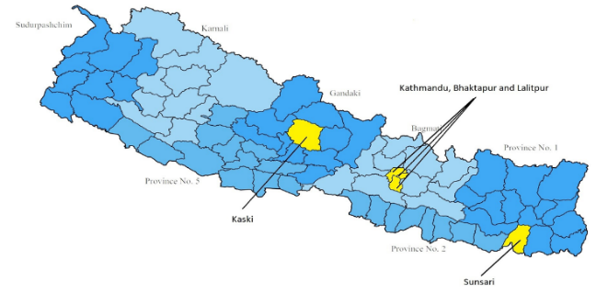
Mission:
“To empower Women Who Use Drugs and organizations workings with Women who use drugs to accelerate the transition of policies and programs that advance social justice and human rights".

Vision:
“We envisage WUDs living a dignified, healthy and proactive life in the society

Goal:
"Ensure meaningful involvement of WUDs in Nepal at all phases of policy formulation and programming: assessment, analysis, planning, implementation, monitoring and evaluation".

RN Women Structure

General Assembly

Executive Board Members

Implementing Partners (5 District and 22 staffs)

RN Women Staff members under global fund project
S.N | Designation | No. of Staff
1. | Program Co-ordinator | 1
2. | Finance Officer | 1
3. | Monitoring and Evaluation Officer | 1
4. | Support Staff | 1

RN Women Implementing Partners under Global Fund Project
District | Organization | No. of Staffs
Kathmandu | Sober Female Rehabilitation & Treatment Center
  Program officer | 1
  IRWs | 3
  Waste Management Assistant | 1
  Support Staff | 1
Bhaktapur | Sober Female Rehabilitation & Treatment Center
Lalitpur | Women’s Support Group (WSG)
  Program officer | 1
  IRWs | 2
  Support Staff | 1
Kaski | Community Support Group (CSG)
  Program officer | 1
  Finance Assistant | 1
  IRWs | 4
  Support Staff | 1
Sunsari | Jagaran Arogya Samuha (JAS)
  Program officer | 1
  Finance Assistant | 1
  IRWs | 3
  Support Staff | 1

Major Activities of RN Women
- Mobilizing Drop In Centers (DIC) in 5 districts i.e. Kathmandu, Bhaktapur, Lalitpur, Sunsari and Kaski.
- Collecting data from all the implementing partners, help support them wherever possible in order to run/ process it smoothly.
- Engage in meaningful and higher level meetings in order to empower as well as polish women drug users to be able to fight for their rights and freedom.
- To strengthen and establish women-led, gender-friendly, and accessible harm reduction services emphasizing mainly on WUDs/WWID
- Advocacy and sensitization program targeting concerned stakeholders to create an enabling environment for WUDs to access services addressing violence as well as Human Rights of people who use drugs.
- To reform policy in order to accomplish gender equality and explore for the provision of sustainable funding from the governments at all levels.
- Interaction meetings with various stakeholders, government bodies, NGOs/ INGOs and CBOs to strengthen network.
- Mobilize various events, programs be: World Drug day, Support Don’t Punish, Women’s Day or World AIDs Day for the future benefit for our drug users community by advocating or sensitizing over the concerned subject.
- Implementing staff as well as board meetings
- Monitoring and Evaluation visit at 5 districts
- Frequent visit to and from Save the Children and UNDP
- National Consultation Program
- Establishing relationship with NCASC (National Center of AIDS and STD Control), MoHP
- Approval from local bodies and SWC

Save the children project of WUDs/WWID till January 2025 & UNDP From February 2025
Organization: | RN Women (Network of Women Who Use Drugs in Nepal)
Project Title | “Comprehensive Prevention Programs for people who inject drugs (PWID)” and "Community System Strengthening" and "Strengthening Health Resilience In Nepal: HIV, TB and Malaria
Contact Person:  Title / Position: | Asmita Chauhan  Program Coordinator
Country: | Nepal
Reporting period: | Fiscal year 081-082 (July 2024 – July 2025)
Budget in Rupees | NPR. 1050762.24

Activities carried out by implementing partners

S.N | Activities carried | Organization/District | No. of event | Date
1. | Stakeholder’s Meeting | Sober Female Rehab/KTM+BKT | 8 | 27th september, 23rd October, 27th October & 23rd December, 27th December 2024
1. | Stakeholder’s Meeting | Women’s Support Group / Lalitpur | 4 | 23rd September 2024
1. | Stakeholder’s Meeting | Jagaran Arogya Samuha /Sunsari | 4 | 23rd September, 17th November 2024
1. | Stakeholder’s Meeting | Community Support Group/ Kaski | 4 | 26th September, 16th December 2024
2. | Interaction with Security Personnel  Women’s Support Group / Lalitpur | SOBER Female Rehab/Ktm+Bkt | 7 | 24th September, 27th September, 18th December, 20th December
2. |  | Women’s Support Group/ Lalitpur | 4 | 30th September, 16th December 2024
2. |  | Jagaran Arogya Samuha/ Sunsari | 3 | 24th September,28th November
2. |  | Community Support Group (CSG)/ Kaski | 4 | 22th September, 20th November 2024
3. | Joint Monitoring Visit | SOBER DIC(Ktm+Bkt) | 2 | 20th November 2024
3. | Joint Monitoring Visit | Women’s Support Group/ Lalitpur | 2 | 27th December 2024
3. | Joint Monitoring Visit | Jagaran Arogya Samuha | 2 | 25th October 2024
3. | Joint Monitoring Visit | Community Support Group(CSG)/ Kaski | 2 | 25th October 2024
4. | Monthly Review Meeting | SOBER Female | 12 | Conducted End of every month
4. | Monthly Review Meeting | Women's Support Group | 12 | Conducted End of every month
4. | Monthly Review Meeting | Jagaran Arogya Samuha | 12 | Conducted End of every month
4. | Monthly Review Meeting | Community Support Group | 12 | Conducted End of every month

Activities carried out by RN Women

M&E Visit was completed to Kathmandu, Lalitpur, Kaski and Sunsari
Monitoring visit was successfully completed 4 times to all the Drop-In Centre each of Kathmandu, Lalitpur, Kaski and Sunsari. The objective of the meeting was to
- Cross verify all the documents such as daily dairy, log-sheet, CLT register, HIV test result form.
- Review all the documents such as staff profile,
- Variance of DHIS2 and Reports
- Stock Verification
- Interaction with PO, Finance Assistance and IRWs
All the documents dairy, log-sheet and DHIS2 were reviewed and all the identified errors were corrected. As per the observations, all the partners were provided with the recommendations and timeline. Provided recommendations were followed up whether it has been followed up within the timeframe or not.
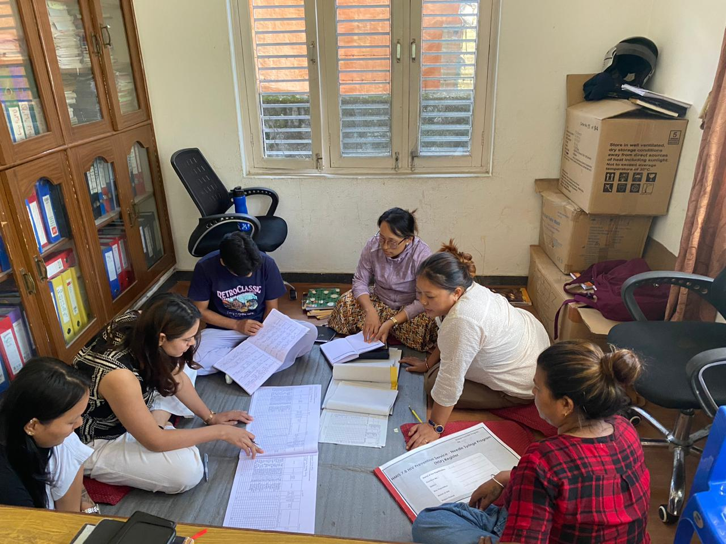
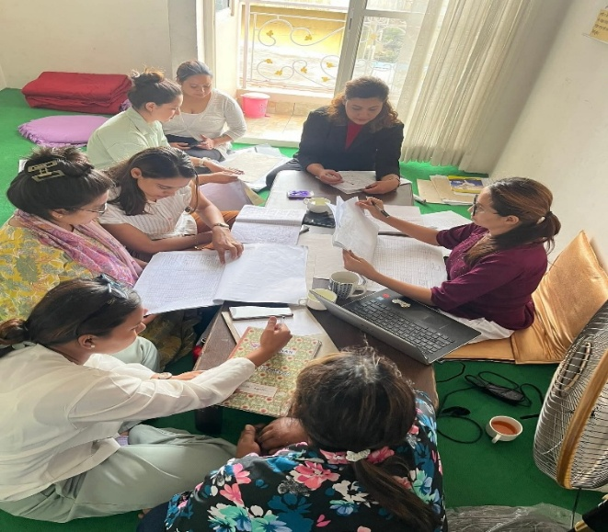
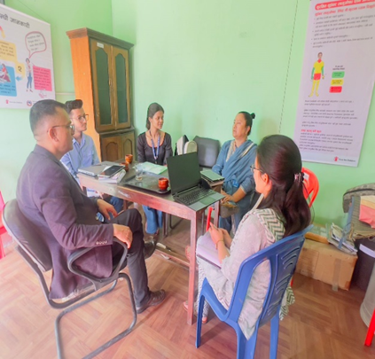
Similarly, staff contract, staff profile and physical as well as stock book were verified where all the records we properly documented.

Board Meeting
Board Meeting was conducted on 17th July 2024, 6th November, 19th November 202, 16th January 2025, 7th March, 17th April, 6th June,19th June, 2nd July 2025 with the following agendas
Meeting/workshop agenda
  - Updates on upcoming activities of RN Women PWID component
  - Updates and information regarding Harm Reduction Services.
  - Updates Monitoring & Evaluation / Onsite Data Verification Visit to province
  - Updates on upcoming program and planning for next phase for GC7 grant
  - Updates and information regarding the audit and renewal process of RN Women
  - Updates on Finance and Budget
  - Introduction of new staffs and proposal development
  - Planning meeting for Drug day and Women in Advocacy

Output of the Meeting
- Physical and active participation of all the board members.
- Informed all the board members about the activities that RN Women has been implementing.
- Explored and submitted different proposal to different donors.
- Updated board members on the update of the budget and expenses.
- The process of the organization renewal and audit has been started.
- Each event was planned and some of the carry forwarded events was conducted accordingly.
- Several misunderstandings and confusions were cleared
- Staffs are hired based on policy and experience

Support Don’t Punish Campaign
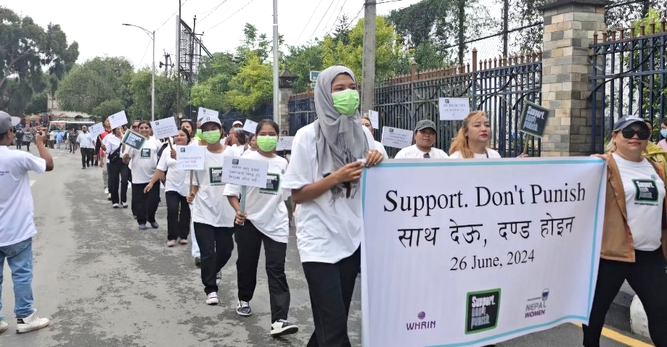
Recovering Nepal Women, a National Network of Women Who Use Drugs, with support from NAPUD, conducted an interaction meeting with Ministry of Health, Nepal Police Department, local government, various like-minded organizations, and beneficiaries as part of the "Support. Don't Punish" campaign, a Global Day of Action 2025, focused on women drug users. The primary focus of the meeting was to highlight use of drug is not a crime instead it is a health issue. The discussion emphasized on the need to support drug users with love and care rather than stigmatization and discrimination. The participants were informed regarding the Narcotics Drug Control Act 2033 in Nepal which outlines two alternative solutions to avoid criminal cases against drug use: Opioid Agonist Treatment (OAT) and Drug Treatment and Rehabilitation Centers out of which OAT is considered as the most effective method. The OAT services was welcomed by the participants, and government stakeholders expressed their agreement that drug use should be treated as a health issue. They assured their support for initiatives aimed at supporting drug users.
Moreover, RN Women participated in the National Program wearing t-shirts of "Support. Don't Punish" with around 35 participants, including recovering drug users and current drug users. RN Women stood out among all by promoting the "Support. Don't Punish". This provided significant visibility for the campaign among a large audience. The issues were addressed using slogans like "Stop Stigma and Discrimination against Women Who Use Drugs," "End Violence against Women Who Use Drugs," "Human Rights are For Everyone, "Drug Use is a Mental Health Issue and "Discrimination is Unacceptable". Key guests at the event included the Minister of Youth and Sports, the Minister of Education, Science and Technology, the Minister of Health and Population, and the Minister of Home Affairs of Nepal where RN Women engaged with the ministers regarding the issues faced by drug users, particularly stigma and discrimination.
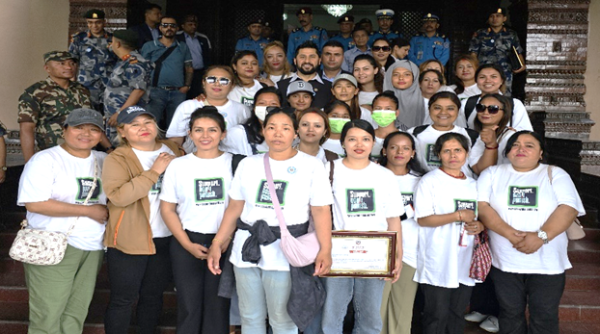
Overall, the events were highly successful, raising awareness, fostering support, and promoting the rights and well-being of Women Who Use Drugs in Nepal.

Extra Activities

SR review meeting 12-13 December 2024
A two-day SR Review Meeting was successfully conducted at Hotel Landmark, Pokhara, on 12–13 December 2024. The meeting brought together all Sub-Recipients (SRs) to review and present their performance based on the target indicators for the period of August to November 2024.
During the review sessions, each SR shared progress updates, key achievements, and performance outcomes against agreed indicators. The presentations focused on results, challenges, and strategies for improved implementation in the upcoming period.
The RN Women Team Leader Mrs. Sujata Khadka made a comprehensive presentation covering the following areas:
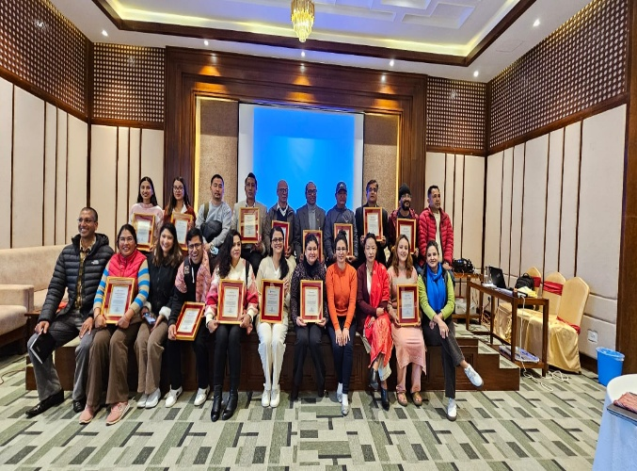
- Organization Introduction and Staff Structure
- Program Coverage
- Program Progress – HR
- Program Progress – Cascade
- Commodities Utilization
- Budget Utilization
- Best Practices and Lessons Learned
- Key Challenges and Ways Forward/Recommendations
Key highlights from the presentations included effective implementation strategies, efficient utilization of commodities and budget, and identification of lessons learned to enhance program delivery. The meeting also provided a platform for open discussion and peer learning among SRs.
Action Pictures:
Photographs of the event were taken, capturing key moments such as the presentation sessions, group discussions, and interactive activities that reflected the active participation and collaborative environment of the review meeting.
Conclusion:
The SR Review Meeting served as a valuable opportunity to assess performance, share experiences, and plan for the next implementation period. Participants expressed commitment to address identified challenges and strengthen program outcomes moving forward.

Provincial-level annual review on HIV, sexually transmitted diseases, hepatitis, and OST/N-related programs
The Provincial Annual Review Meeting was held with active participation from RN Women in NHTC. The RN Women Program Coordinator, Ms. Asmita Chauhan, presented the annual targets versus achievements of all five major districts under the RN Women program.

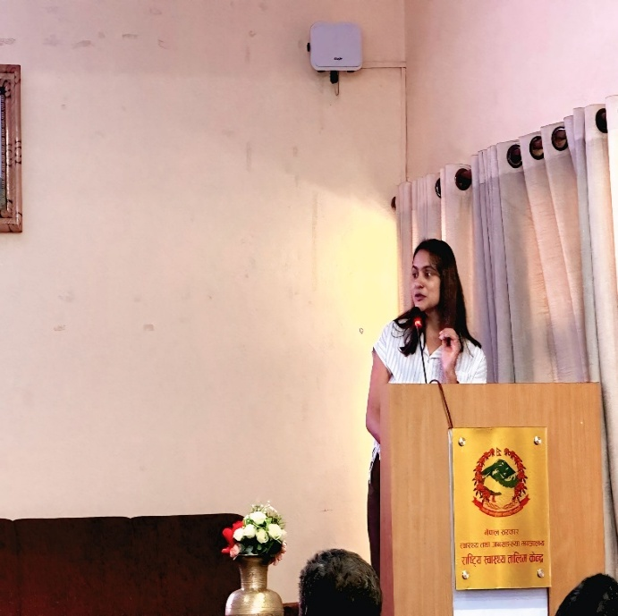
The session was highly interactive, with all participating organizations and ART centers
Presenting their updates related to HIV. Mr. Sarbesh Sharma, Director of NCASC delivered the opening remarks, highlighting the importance of collaborative efforts in HIV response.
Mr. Jitendra Yadav, the Provincial HIV Focal Person, provided information on the current HIV status in Nepal and discussed the challenges faced during service delivery.
The meeting successfully facilitated knowledge sharing, reflection on achievements, and discussion of strategies to overcome ongoing challenges in HIV program implementation.

Program Target Vs. Achievement of 2081/082

RN Women Harm Reduction Target Vs. Achievement

The above chart shows the overall target vs. achievement as well as HIV testing of RN Women. The graph shows that out of 1527 target for fiscal year 081/082, RN Women achieved 1354 which is 86.9% of the target. Out of 1327 beneficiaries, 1113 beneficiaries were tested for HIV, where all were non-reactive.

BCC Reach Vs. Achievement of 081/082

The above graph shows the district-wise target vs. achievement of the fiscal year 081/082 where Bhaktapur has shown remarkable achievement with 99% of client reach. Similarly, Kaski and Sunsari has achieved the same percentage which is 93% of their target followed by Kathmandu and lalitpur i.e. 75% and 86% respectively. Looking at the overall progress, Kathmandu achievement is below 80% which is due to the project transition phase from SCI to UNDP and also due to frequent stock out of commodities and staffs turnover at the same time.

BCC Reach and HIV testing

The reach of beneficiaries and the number of HIV testing performed on fiscal year 081/082 has been shown in the above bar diagram. It shows that Kaski has almost tested HIV of all the beneficiaries who were reached and Bhaktapur has tested 77.5% of the beneficiaries reached. However, Kathmandu, Sunsari and Lalitpur have tested HIV of less than 80% of their reached beneficiaries where Kathmandu reached just 37.8% of reached.

Syringe Distribution

The above bar diagram shows the target vs. achievement of the syringe distributed to the beneficiaries where it can be seen that Sunsari has distributed 90% of the given target, Lalitpur has distributed 83% of the given target, whereas the syringe distributed by Kaski, Kathmandu and Bhaktapur is low as the syringes are distributed as per the need and demand of the beneficiaries.

Syringe OUT/Syringe IN

The graph above shows the comparison of number of syringe distributed to beneficiaries and the number of used syringes collected by IRW from beneficiaries as well as spot collection. It can be clearly seen that the number of syringe in and out is not equal, none of the districts has been able to collect all the syringes provided to the beneficiaries due to the fear of being caught by family and police personnel. However, as compared to the other district Lalitpur has collected 60% of the used syringes.

Syringe Out and Syringe per person per month

The graph depicts the total syringe distributed and average number of syringe received by the beneficiaries per person per month. This graph shows that beneficiaries of Lalitpur AND Kathmandu receives 15 syringes in average in a month, while beneficiaries of Kaksi receives 11 each followed by Bhaktapur and Sunsari which is 10 and 7 respectively.

Condom Distribution

The above graph shows the number of condom distributed to the beneficiaries in fiscal year 080/081 where Sunsari has distributed more number of condom compared to other districts i.e. 14,057.

Conclusion
On fiscal year 081/082, the target activities were completed by the central office RN-Women as well as the partner organization of RN Women. All the activities could not be completed as per the plan due to certain circumstances, however it was done within the time frame of the project. RN Women also participated in several meetings and trainings apart from the project activities which has been well documented. Similarly, looking at the overall progress of the districts, Kaski performance has been very good in every way, however out of 5 district Kathmandu has not been able to stand out in-terms of testing and overall performance despite of their continuous effort.

Annex: I
Membership Organization of RN Women
S.N | Name of Organization | Province | District | Contact Person | Phone Number | Email
1 | Women's Support Group | Bagmati | Lalitpur | Ms. Sarmila Baidhya | 9808776070 | wsgkathmandu@gmail.com
2 | Shubharambha Rehabilitation Centre | Bagmati | Lalitpur | Ms. Sarita Lama | 9840619405 | subharambharehabilitation@gmail.com
3 | Grace Foundation | Bagmati | Lalitpur | Ms. Bigens Nembang | 9860132031 | bigensnembang@gmail.com , gracefoundation@gmail.com
4 | Sahara Female Foundation | Bagmati | Kathmandu | Ms. Prachi Sunuwar | 9818954561 | anniesunuwarrai@gmail.com , saharafemalefoundation2022@gmail.com
5 | Sober Recovery Treatment and Rehabilitation Centre | Bagmati | Kathmandu | Ms. Yamkala Rai | 9823217349 | soberfemale2066@gmail.com
6 | Bhawani Sewa Samaj | Bagmati | Kathmandu | Ms. Doma Sherpa | 9823578719 | domasherpaa8@gmail.com
7 | Ekata Nepal | Bagmati | Chitwan | Susmita Gurung | 9843801594 | ekatanepal2064@gmail.com
8 | Siyaan Rehabilitation Centre | Bagmati | Makwanpur | Ms. Tanya Agarwal | 9861612636 | siyaanfidu@gmail.com
9 | Neeta Rehabilitation Centre | Bagmati | Makwanpur |  |  | neetafemale@gmail.com
10 | Punarjanma Punarsthapana Kendra | Bagmati | Rupandehi | Ms. Bhawana Basyal | 9825427676 | punarjanmapurnaisthapanakendra@gmail.com
11 | Community Support Group | Gandaki | Kaski | Pratichha Gurung | 9846171631 | dlip70@gmail.com , hrfidu.csg.kaski@gmail.com , rnwomen_kaski@rnwomen.com
12 | Naulo Ghumti Nepal | Gandaki | Kaski | Mr. Anesh Gurung | 061-402070 | naulo-ghumti@ngn.org.np , anesh.gurung@ngn.org.np
13 | Aasha Foundation | Lumbini | Rupandehi | Mr. Mohan Pandey | 9857059565 | ashafoundation2069@gmail.com
14 | Damayanti Foundation Nepal | Lumbini | Banke | Ms. Indu Rawal | 9858028282 | dfn.nepalgunj@gmail.com
15 | Manav Sewa Bikash Kendra | Lumbini | Banke | Ms. Manju Shah | 9819420074 | manavsewabikashkendra@gmail.com
16 | Better Destiny Rehabilitation Centre | Lumbini | Nawalparasi | Ms. Ashu Joshi | 9803441500 | betterdestiny2080@gmail.com
17 | Naya Drishti Female Rehabilitation Centre | Lumbini | Banke | Ms. Rashi Rawal | 9848264228 | nawadrishtifemalerehab@gmail.com
18 | Jagaran Aarogya Samuha (ACT Nepal) | Koshi | Sunsari | Ms. Gauri Sampang Rai | 9800979040 | jagaranarogyasamuha@gmail.com
19 | Aina Nepal | Koshi | Sunsari | Ms. Sarala Tamang | 9823322176 | ainanepal6688@gmail.com
20 | Santa Jeevan Pratisthan Nepal | Koshi | Jhapa | Mr. Pujan Khatri | 98279962126 | serenelifefoundationnepalkrm@gmail.com

